Student Resource 12.2
Reading: Overview of Health and Disability Insurance
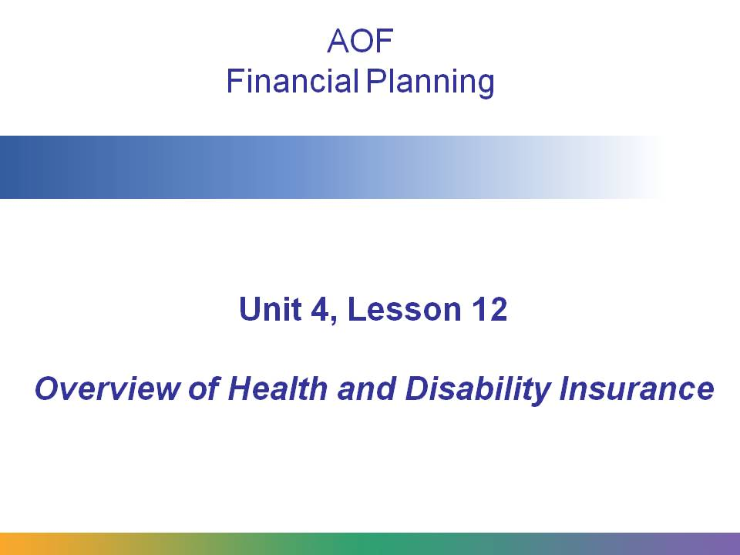
This presentation covers the main types of health and disability insurance and explains some key terms related to health care insurance.
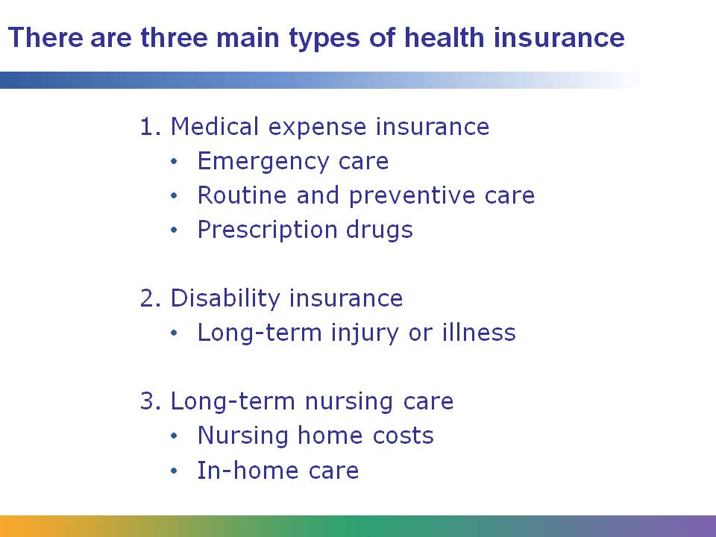
There are three main types of health care insurance:
Medical expense insurance covers not only emergency care but also routine care, preventive care, and prescription drugs. When most of us think of health insurance, this is the kind of insurance we are thinking of.
Disability insurance provides financial assistance if you are unable to work due to long-term injury or illness. This is a very important kind of insurance, because losing several months’ wages when you are out of work could cause serious financial harm!
Long-term nursing care provides coverage if a person needs to stay in a nursing home or have nurses stay in the home. The costs of several months or even years of home care can eat up retirement savings.
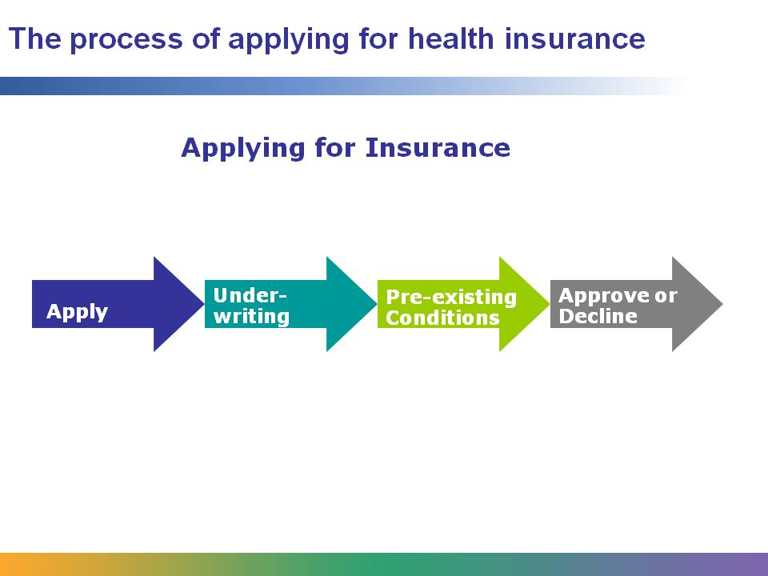
When you apply for health insurance, you must usually fill out a form that asks lots of questions about your health history. You may even have to undergo a physical examination. This is called the medical underwriting process. The insurance company is trying to learn if you have any pre-existing medical conditions. If you do, some insurance companies will not cover you at all, some may accept you conditionally, and others will charge you higher premiums.
However, as of March 2010, children under the age of 19 may not be denied coverage based on a pre-existing condition. The Patient Protection and Affordable Care Act signed into law by President Obama states that insurance companies may not deny children access to their parents’ health plans or exclude treatments for a pre-existing condition. Beginning in 2014, this law will also apply to adults.
Why do you think insurance companies often decline (while they legally can) or charge more for people with pre-existing conditions? Do you think the practice is fair? Why or why not?

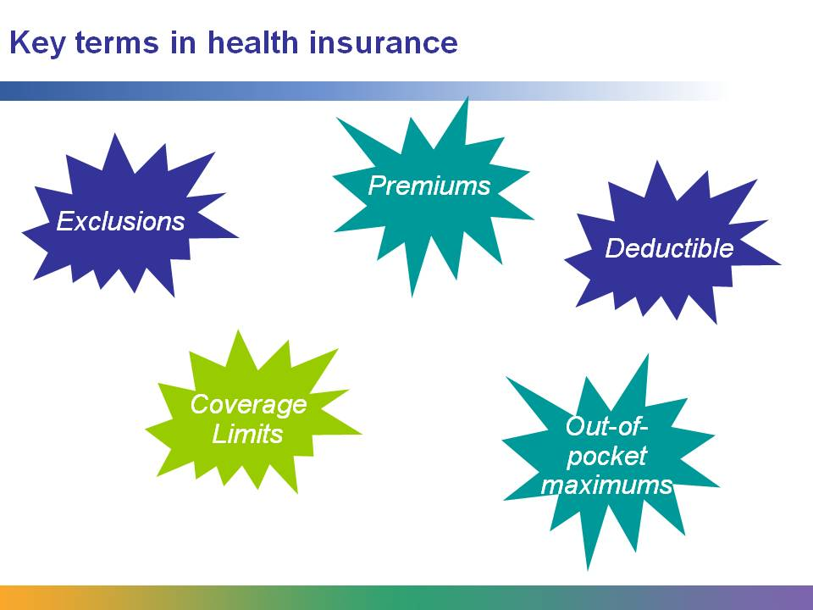
Once you are covered, there are some things you need to know:
All insurance policies have a list of things they will not cover or only provide partial coverage for. These are called exclusions. Read the terms of your policy carefully to see what the exclusions are.
All insurance plans require premiums. This is the amount you must pay each month to be part of the plan. If you are on an employer-sponsored plan, your employer may be paying some or all of the premiums for you.
Many plans have deductibles, which is the portion of the bill that the patient must pay for the medical treatment. Usually, the higher the deductible, the lower the premiums.
Some plans have an “out-of-pocket maximum.” This means the patient pays all bills up to a certain amount, and then the insurance company covers the bills after that. Usually, the higher the out-of-pocket maximum, the lower the premium.
Finally, some plans have coverage limits, which means they’ll pay up to a certain amount, and after that the patient is on his own. Can you see any problem with coverage limits if they are set too low?
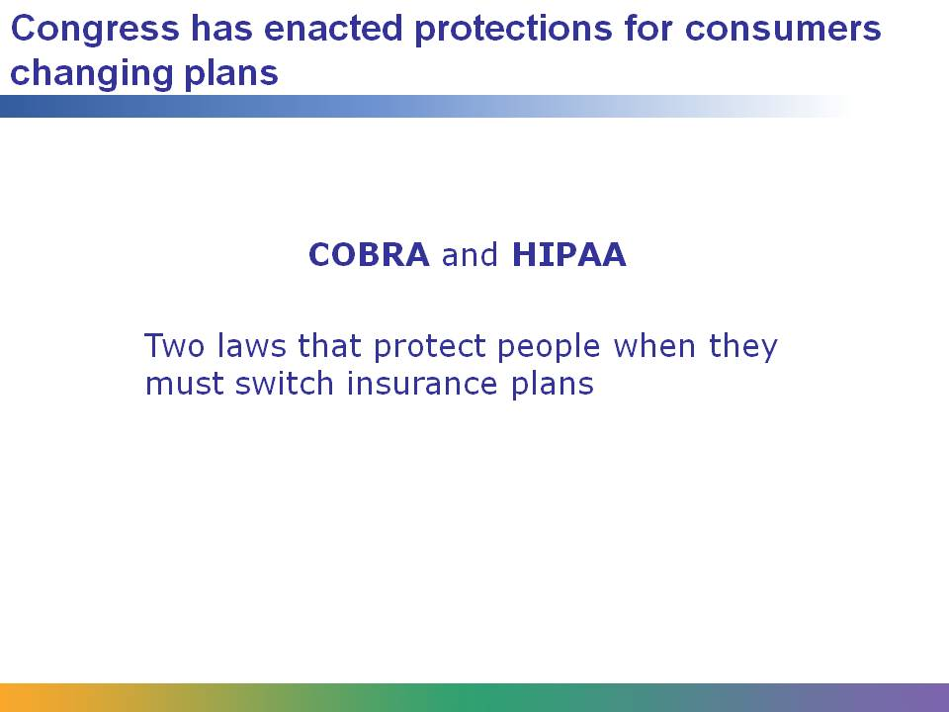
When people change jobs or become unemployed, they often lose or must change their health insurance plans.
In the past, this caused problems for people with pre-existing medical conditions, because sometimes they could not get health insurance again or would have to pay much higher premiums.
To protect people, Congress passed two special laws, known as COBRA and HIPAA for short. These laws enable people who are leaving a health insurance plan (usually because they are changing employers or are laid off) to join a new plan, and provide protection against being rejected for a pre-existing condition. Both of these plans allow only a set period of time that this switch can be made. After that, the consumer faces medical underwriting like anybody else!

